Teachers’ Guidelines
Title of the package: Air pollution in polar regions
Information about the package:
Brief Description: Package is focused on the problem of air quality in polar regions. It explains how to define air pollution, presents main air pollutants, their local sources and the problems that they cause in polar environments.
How does the package relate to STEAM education: Package combines knowledge from different science disciplines through interactive learning resources. Its aim is to engage students in explaining various environmental processes on their own.
Keywords: air pollution, polar regions, climate change, ozone hole, Arctic haze
Age Range: 12+
Didactical Hours: 3 didactical hours
Learning objectives:
The student will (understand, know, be able to…)
- understand what air pollution is
- know the main pollutants and their influence on the environment
- recognize the interdependencies between weather and air quality
- be able to check air quality anywhere in the world
Content of the package:
Link to the package: https://graasp.eu/s/6rmy7j
Package is divided for 8 parts:
- Section “Introduction”
Short video material showing the problem of air pollution:
https://www.youtube.com/watch?v=e6rglsLy1Ys
- Section “Main pollutants”
Three video materials presenting the most important chemicals that pollutes air
https://oceantoday.noaa.gov/blackcarbon/# Video introducing the black carbon and its influence on warming the Arctic
https://www.youtube.com/watch?v=2ri95j0cShg Video explaining what chemicals are produced by process of hydrocarbon combustion
https://www.youtube.com/watch?v=FSBydPkLEII Material illustrating the problem with carbon dioxide and its influence on Earth warming
Infographic about methane as a one of greenhouse gases
- Section “Local sources”
Interactive map showing toxic hotspots of the Arctic together with its brief description
Infographic presenting sources of air pollutants in polar regions
Link to NASA Earth Observatory material regarding Arctic wildfires observations from satellites
Word search puzzle game in which the student guesses the phrases related to the formation of air pollutants
- Section “Weather and pollution”
Model explaining connection between weather and air quality allowing to set meteorological parameters (wind speed and direction, air temperature, solar insolation, and precipitation frequency) as well as modifying pollutant sources (car traffic and power plants amount)
Quiz about air pollutants behaviour in different weather conditions
- Section “Effects”
Interactive flip card presenting the Arctic haze phenomena occurrence in Svalbard
Photography with interactive elements showing air pollutants accumulated beneath inversion layer over the glacier
Video material explaining what are chlorofluorocarbons (CFCs) and its influence on ozone depletion
https://www.youtube.com/watch?v=aU6pxSNDPhs
Infographic about the effects of air pollution on polar wildlife
Exercise where students are asked to point regions on Earth map where selected consequences of global warming will be the most pronounced
- Section “Air quality inspection”
Exercise where students should note their own observations after exploration of windy app and the data presented there regarding air quality
Link to webpage announcing unhealthy air quality conditions in Alaska state. Student’s objective is to check the date of the last warning message.
Link to the map presenting in real-time air quality in most countries of the world
Link to alternative map with data from air quality sensors
Table tool where students have to write air pollutants concentrations from last 7 days from chosen Arctic location and compare it with data from the station close to their living place
Exercise where students interpret historical data about air quality. Objective is to recognize the diurnal and annual variations in pollutants concentrations and connect the results with weather conditions.
- Section “Scientist efforts to recognize air quality in polar regions”
Short text with illustrations explaining what researchers studying the atmosphere do in polar regions and why it is important.
- Section “Wrap-up”
Three interactive flip cards presenting clues from which students need to guess what type of air pollutant (or connected with pollution phenomena) is on the other side of card
Quiz checking the knowledge
Matching column game where student’s mission is to pair chemical to its characteristics and effect on the environment
Guidelines for teachers:
Describe here all phases of the activity. Provide information on suggested tools and materials. Add tips, how to use them.
- Introduction
- Main pollutants
Better quality of video about black carbon can be found in original source webpage that cannot be embedded into graasp: https://oceantoday.noaa.gov/blackcarbon/#
- Local sources
All available interactive elements are displayed after clicking the icon with hand in top right corner. Some elements are displayed when you hover the mouse over them, others require a left-click.
Infographic regarding source of pollutants is in pdf format. There is a possibility to download the file by clicking on the icon in the top right corner
Materials (infographic, news from the NASA Earth Observatory and word search puzzle game) are not completely displayed on the screen by default – it is required to scroll them using separate scroll bars (or just using the mouse wheel). Links to external sources are not free from commercials so it is recommended to use apps blocking the adds like adblock plus.
- Weather and pollution
Air pollution model may be displayed by default in small window (depending on screen resolution). The easiest way to deal with problem is to zoom the screen using ctrl and + key combination (zoom out by ctrl and -). Model starts work after pressing play button. Model parameters may be changed during its operation – there is no need to pause the simulation.
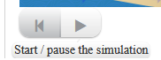
- Effects
Interactive elements are displayed in the same way like those described in section 2. After completing Name the frame activity and clicking the “accept” button in top left corner there should be visible additional “i” buttons. It is worth to click on them and read additional info about the effect. Infographic is in pdf format available for download.
- Air quality inspection
Windy.com app should be open in separate browser window. On the right there should be a list of all layers possible to display. If it is short you should click on „more layers” button. In case the view is not available for whole world for selected layer, there is a need to change the numerical model in the bottom right corner of app (e.g. from CAMS-EU to CAMS).
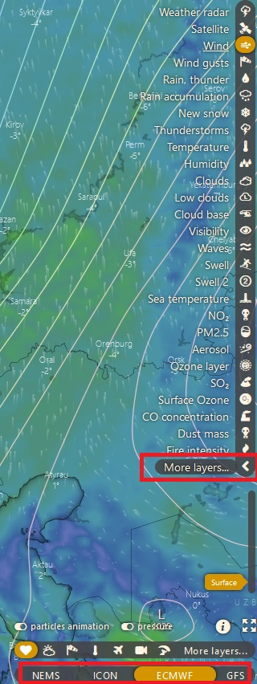
In observations tool new notes can be added by clicking the + sign in the top left corner.
Website with Alaska advisories regarding air quality has to be open in new window. Announcements are presented in table, by default from newest to oldest.
AQI air pollution map may be viewed inside graasp but in such manner it may cause some problems. Opening in new tab should fix all issues https://aqicn.org/map/
Clicking by mouse on selected station should open new window with measurements statistics. In exercise student should fill the table with data from “Air Quality Historical Data” field. Not all stations provide such information. If you don’t see such a field below:
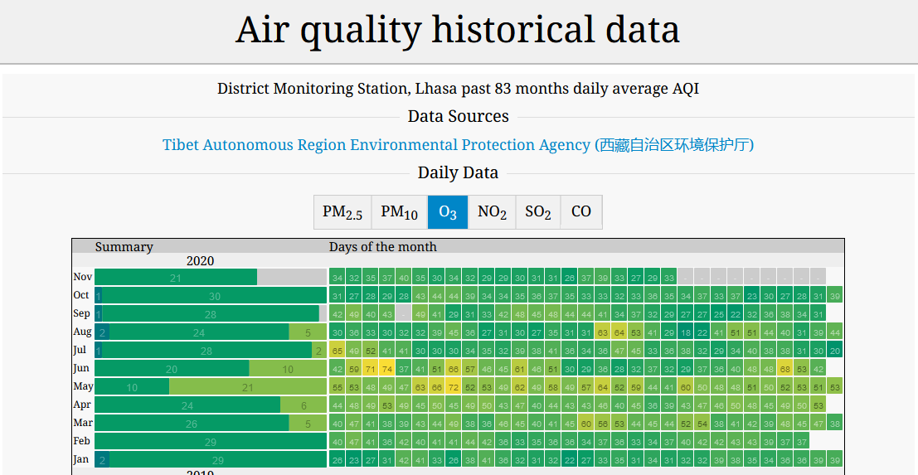
then you should choose different station. Measurements posts marked with table sign (like on map below) should have such data, but those marked with points may present only current situation.
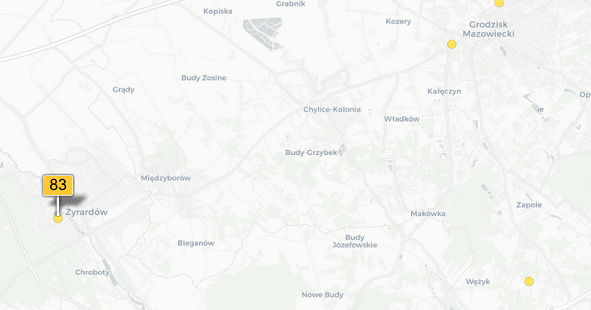

- Scientist efforts to recognize air quality in polar regions – section contains only text with pictures
- Wrap-up
On first two flip cards „Recognize the pollutant” you should click on solution button when you already know what pollutant is described by hints revealed by hovering over the question marks. The answer on third card should be entered using keyboard after clicking on solution button.
Last game in educaplay relies on matching the pollutant on the left (by single mouse click) and then pointing on the box describing it from the right (and again clicking the mouse).

Additional resources and links, references:
Additional resources:
Website of Norwegian Polar Institute describing the pollutants influence on Arctic fauna: https://www.npolar.no/EN/THEMES/POLLUTANTS-IN-THE-ARCTIC/
Educational materials from American the Concord Consortium from which air pollution model comes from:
https://learn.concord.org/resources/626/will-the-air-be-clean-enough-to-breathe
NASA resources for kids, regarding the issues connected with air pollution
https://earthobservatory.nasa.gov/blogs/eokids/cleaning-up-our-air/
https://earthobservatory.nasa.gov/blogs/eokids/air-pollution-seeing-small-specks-from-space/
https://earthobservatory.nasa.gov/blogs/eokids/the-ozone-hole-we-need-more-sunscreen/
More information about Arctic Haze from Polarpedia:
https://polarpedia.eu/en/arctic-haze/

Video used in package:
Air Pollution 101 National Geographic
https://www.youtube.com/watch?v=e6rglsLy1Ys
Black carbon:
https://oceantoday.noaa.gov/blackcarbon/#
GCSE Chemistry – Air Pollution #55
https://www.youtube.com/watch?v=2ri95j0cShg
How Carbon Dioxide Warms Planet Earth | NOVA | PBS
https://www.youtube.com/watch?v=FSBydPkLEII
Climate 101: Ozone Depletion | National Geographic
https://www.youtube.com/watch?v=aU6pxSNDPhs

